AtliQ Hardware Sales Analysis

## i. Purpose of the Project:

* Unlock sales insights previously unnoticed by the sales team.
* Provide decision support to optimize strategies.
* Automate manual data gathering processes, reducing time spent on repetitive tasks.

## ii. Stakeholders:

* **Sales Director:** Oversee and implement strategic sales decisions.
* **Marketing Team:** Leverage insights for targeted campaigns and promotions.
* **Customer Service Team:** Enhance customer retention through data-driven strategies.
* **Data & Analytics Team:** Analyse and interpret data trends to generate actionable insights.
* **IT Team:** Ensure seamless integration and maintenance of the automated dashboard.

## iii. End Result of the Project:

* Develop an automated dashboard delivering real-time and comprehensive sales insights.
* Facilitate data-driven decision-making for stakeholders.

## iv. Success Criteria:

* Quantifiable metrics to gauge project success, such as:
  + A 20% reduction in manual data gathering time.
  + Reallocation of saved time to high-value activities.
  + Improved decision-making efficiency and speed.

# Process of Data Analytics

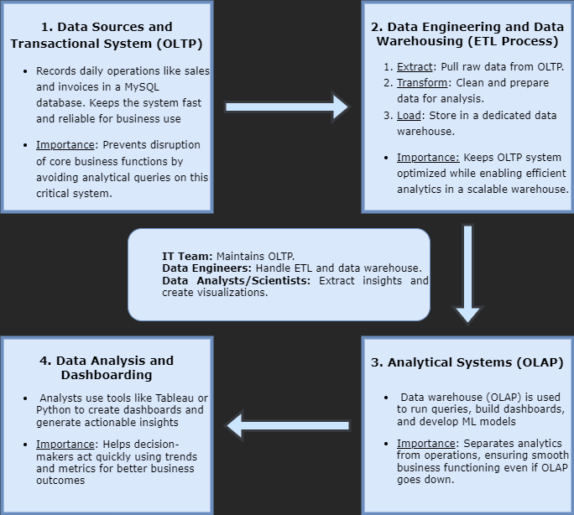

# Insights and Recommendations:

## 1. Month-Wise Sales Pattern:

* **Trend:**
  + Peak performance observed in mid-year (July – August).
  + Decline in sales noted towards year-end (November – December).
* **Solutions:**
  + Plan and execute promotional campaigns during July and August.
  + Ensure adequate stock levels to meet increased demand.
  + Offer year-end discounts targeting industries with unspent budgets.

## 2. Sales Generating Regions:

* **Trend:**
  + North zone, especially Delhi NCR, consistently outperforms other regions in sales volume.
  + However, Delhi NCR also shows the steepest decline in sales over time.
* **Solutions:**
  + Launch region-specific marketing campaigns with a focus on Delhi NCR.
  + Provide discounts and loyalty incentives for existing customers in the area.
  + Invest in digital marketing tailored for Delhi NCR and provide region-specific training to sales teams.

## 3. City-Wise Profit Percentage vs Normalized Sales:

**1. Top Performer:**

* **Delhi NCR** has the highest normalized sales (~519.57M) but a profit percentage of only **2.30%**, indicating high sales volume but average profitability.

2. **High Profitability Regions**:

* Cities like **Bengaluru (-20.78%)** and **Kanpur (-0.49%)** are incurring **negative profit percentages**, meaning these regions may need cost optimization or pricing strategies.

3. **Cities with Balanced Growth**:

* **Surat (4.86%)** and **Bhubaneshwar (3.98%)** have small normalized sales volumes but demonstrate the **highest profit percentages**, showcasing efficient cost management or pricing in these regions.

4. **Growth Opportunities**:

* **Mumbai and Bhopal** show moderate sales volumes (~150M and ~58.6M, respectively) with good profit margins (3.25% and 3.90%). These cities could be further targeted for scaling operations.

## 4. Revenue vs Profit Margin Over Time:

1. **Trend in Profit Margin**:

* Profit margin **peaked in 2018 Q3 (4.2%)**, coinciding with one of the highest revenues (~120M). This may reflect successful campaigns or cost efficiency during that period.
* The **lowest profit margin (0.9%)** occurred in **2018 Q1**, despite relatively high revenue (~80M), suggesting potential cost overruns or pricing challenges.

2. **Steady Decline**:

* A consistent drop in profit margin is observed from **2019 Q4 (2.7%)** to **2020 Q2 (1.0%)**, which may indicate external economic factors (e.g., market saturation, higher costs, or reduced demand).

3. **Revenue Fluctuations**:

* Revenue remains relatively stable across quarters but shows signs of a slight downward trend after **2019**, correlating with declining profit margins.

4. **Actionable Insight**:

* Focus on replicating the strategies from **2018 Q3**, where both revenue and profit margin peaked.
* Investigate the reasons behind lower margins post-2019 and implement cost reduction or process optimization strategies.